**Developer Environment Setup Documentation**

**1. Operating System Installation**

Steps and Screenshots of Windows 11 Installation:

1. Download Windows 11:

- Visit the official Microsoft website: [Windows 11 Download](https://www.microsoft.com/software-download/windows11).

- Download the Windows 11 Installation Assistant.

- Run the downloaded file and follow the on-screen instructions to upgrade or install Windows 11.

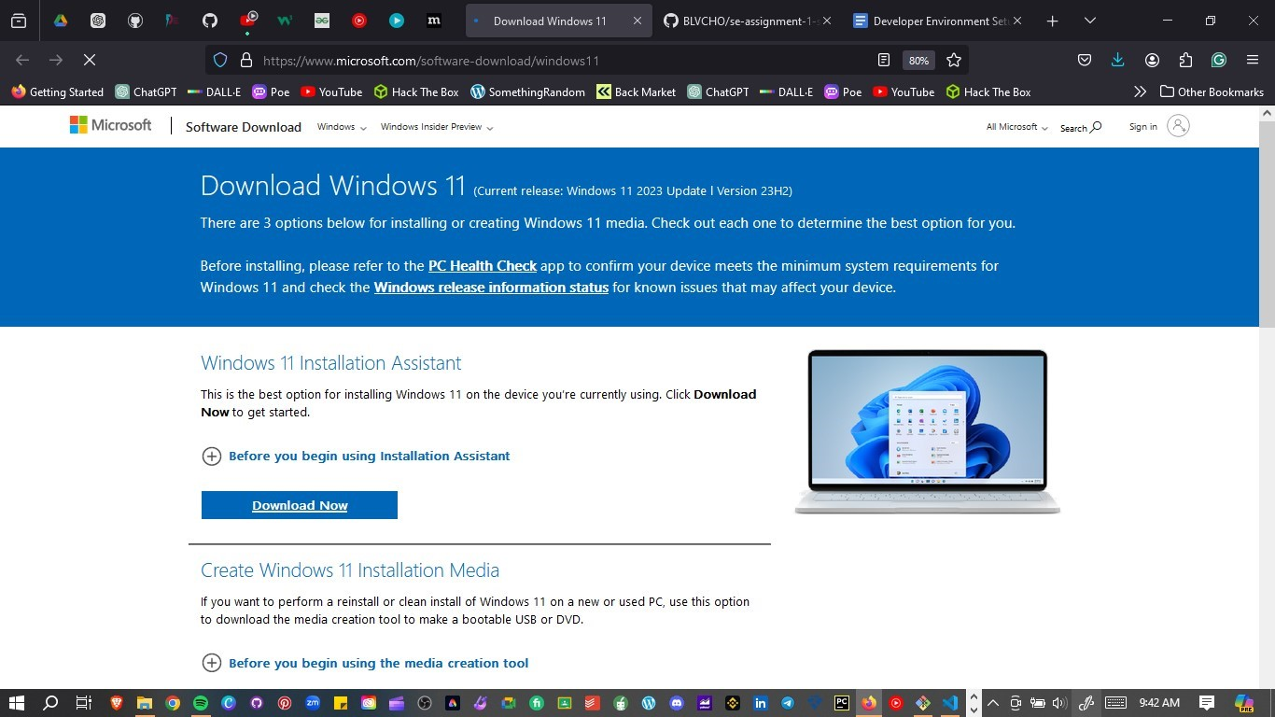

**2. Installation Process:**

- Ensure your PC meets the minimum system requirements.

- Back up your important files.

- Follow the installation steps, including selecting the installation type, partitioning your hard drive if necessary, and configuring initial settings.

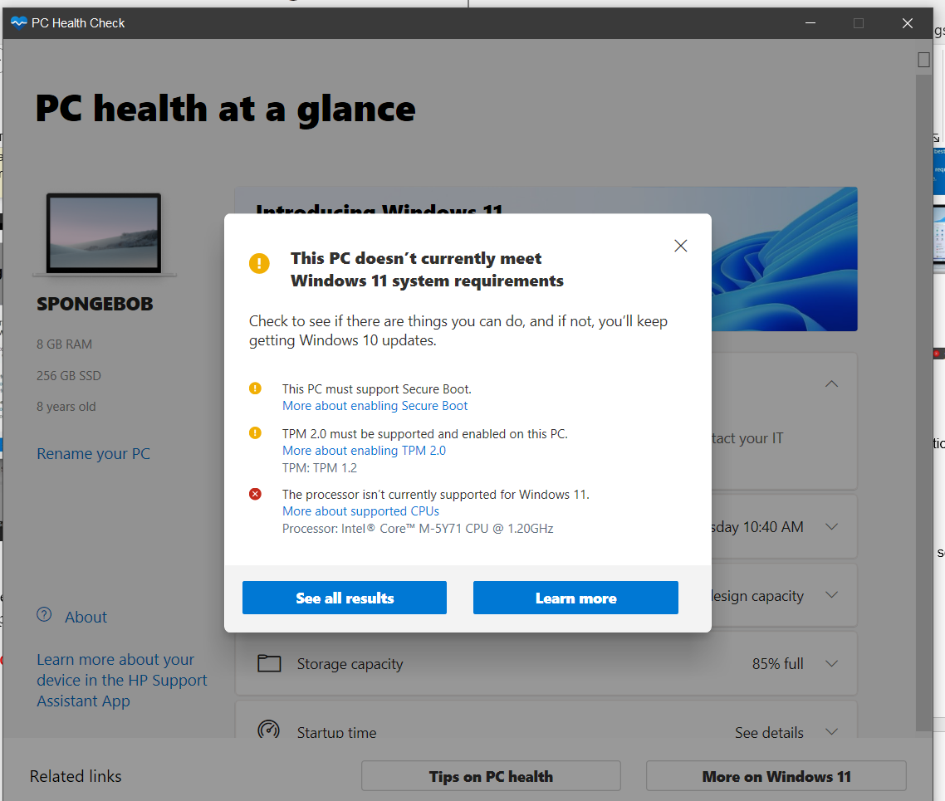

**3. Post-Installation Setup:**

- Configure your user account, regional settings, and privacy settings.

- Install necessary drivers and updates.

NB: MY PC DOES NOT SUPPORT WINDOWS 11

**2. IDE Installation**

Steps and Screenshots of Visual Studio Code Installation:

1. Download VS Code:

- Visit the Visual Studio Code download page: [VS Code Download](https://code.visualstudio.com/Download).

- Select the appropriate version for Windows and download the installer.

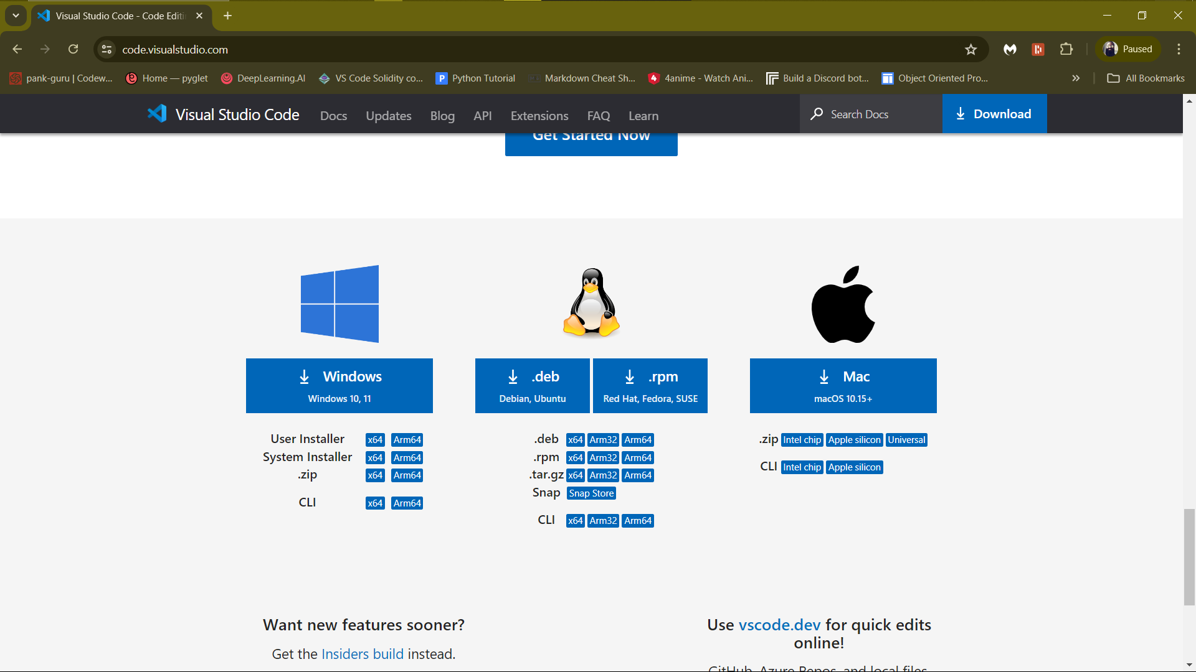

**2. Installation Process:**

- Run the downloaded installer.

- Follow the installation wizard, accepting the license agreement and choosing the installation location.

- Select additional tasks such as adding to PATH and creating a desktop icon.

**3. First Launch and Setup:**

- Launch VS Code and install recommended extensions like Python, GitLens, and Docker.

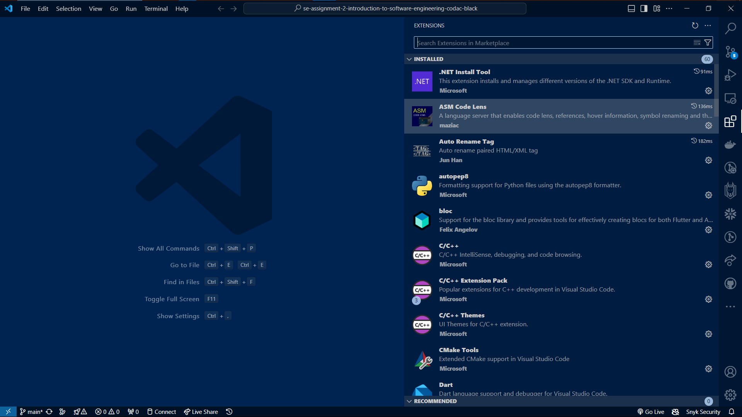

**3. Version Control Setup**

Steps for Installing Git, Creating a GitHub Account, Initializing a Repository, and Making the First Commit:

1. Install Git:

- Download Git from the official site: [Git Download](https://git-scm.com/downloads).

- Run the installer and follow the setup instructions, choosing your preferred options for PATH, line endings, and other settings.

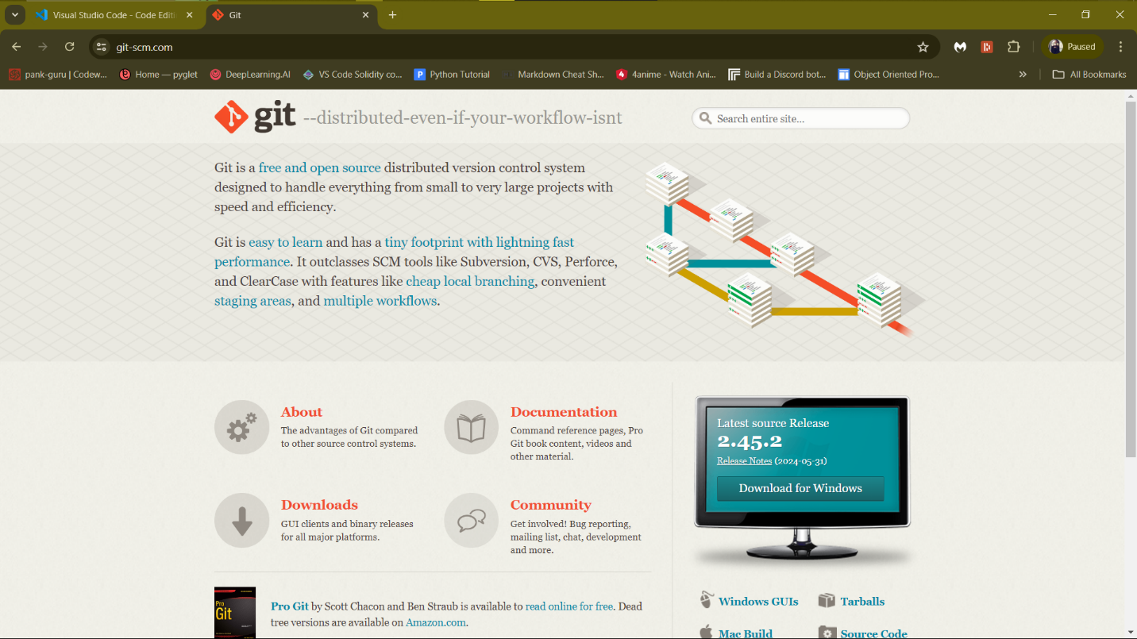

**2. Create a GitHub Account:**

- Visit [GitHub](https://github.com) and sign up for a new account if you still need to get one.

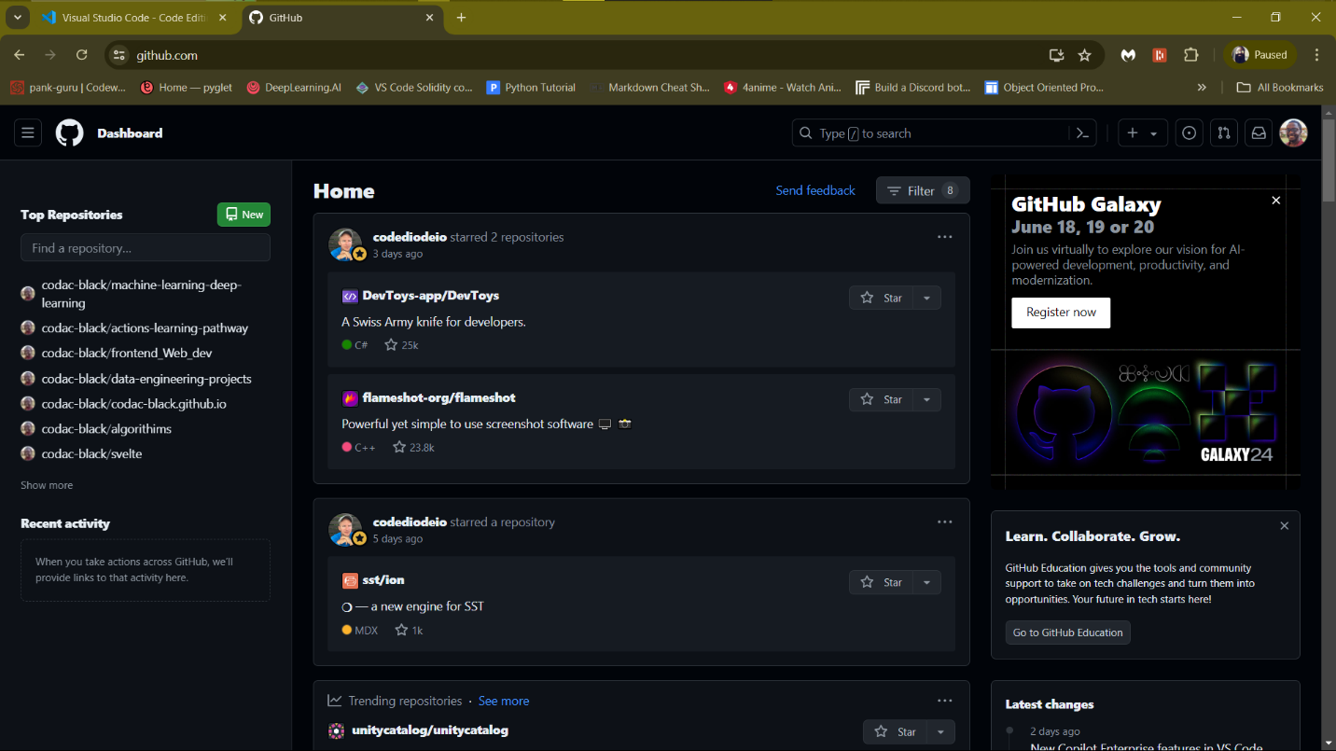

**3. Initialize a Git Repository:**

- Open Git Bash or the terminal in VS Code.

- Navigate to your project directory or create a new one:

*```bash*

*mkdir my_project*

*cd my_project*

*```*

*- Initialize a Git repository:*

*```bash*

*git init*

*```*

*- Create a README file:*

*```bash*

*echo "# My Project" >> README.md*

*```*

*- Add the README file to the staging area:*

*```bash*

*git add README.md*

*```*

*- Commit the changes:*

*```bash*

*git commit -m "Initial commit"*

```

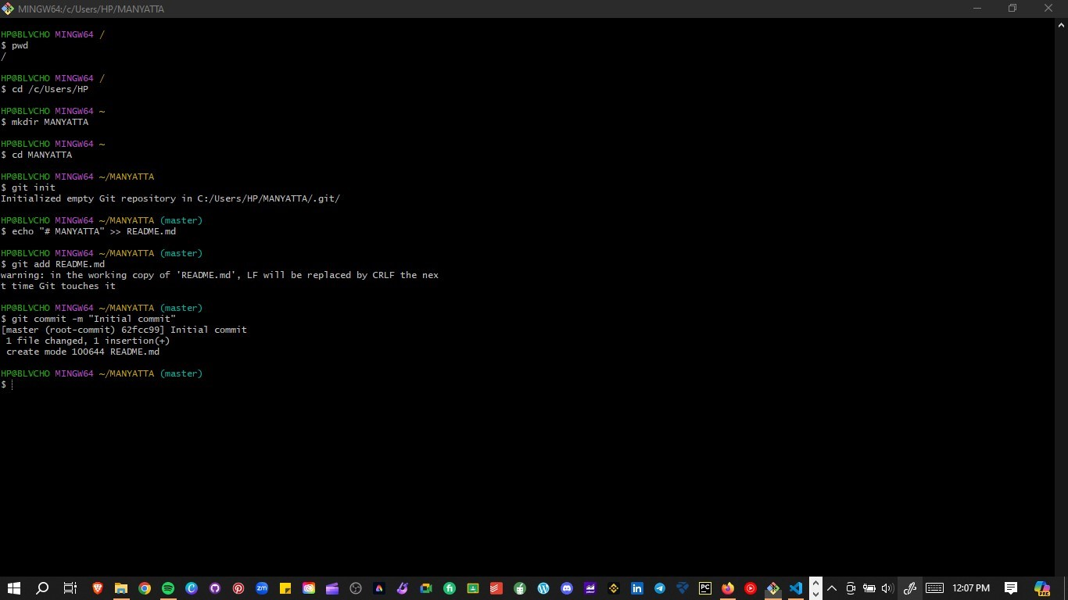

**4. Programming Languages and Runtimes**

Steps for Installing Python:

1. Download Python:

- Visit the official Python website: [Python Download](https://www.python.org/downloads/).

- Download the latest version of Python for Windows.

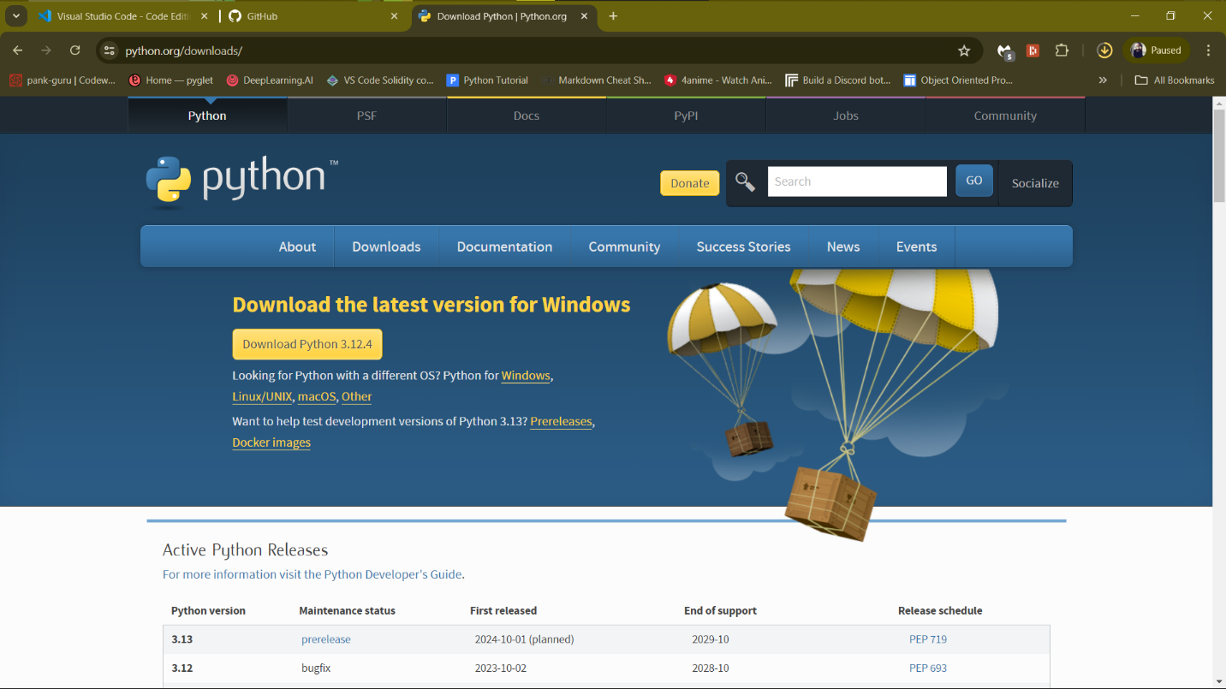

**2. Installation Process:**

- Run the installer, ensure you check the option to add Python to PATH.

- Follow the installation wizard.

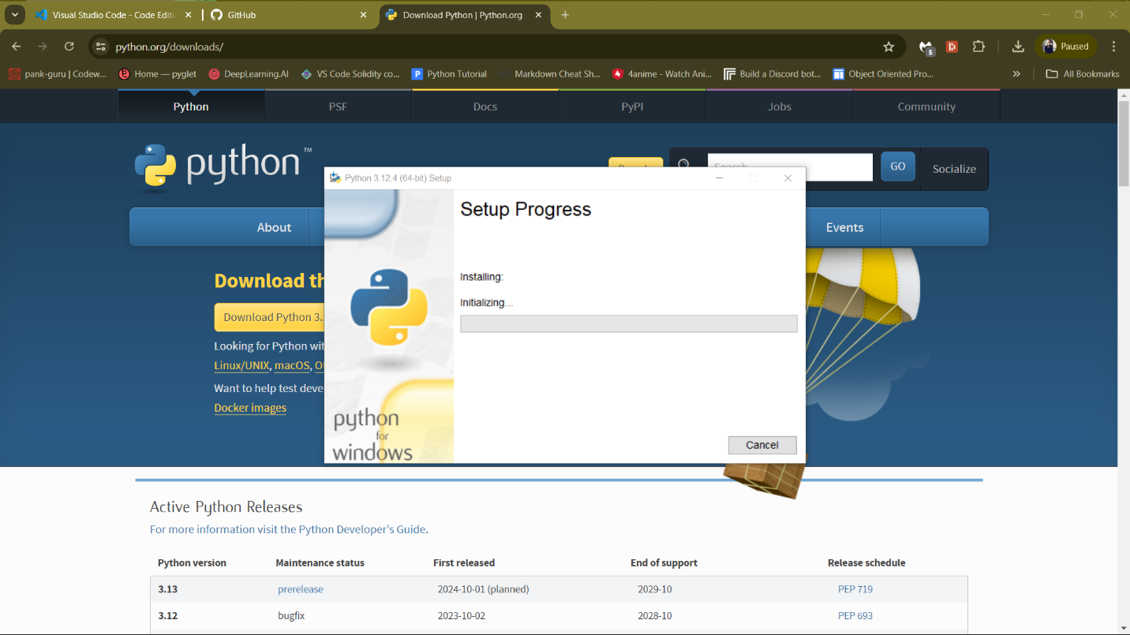

**3. Verify Installation:**

- Open Command Prompt and type:

```bash

python --version

```

- Verify pip installation:

```bash

pip --version

```

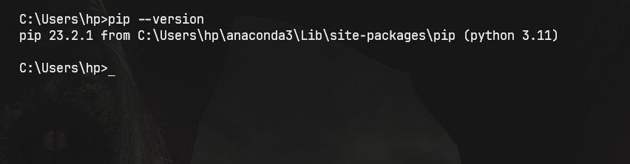

**5. Package Managers**

Verification of pip Installation:

1. Verify pip:

- Open Command Prompt and type:

```bash

pip --version

```



**6. Database Configuration**

Steps for Installing MySQL:

1. Download MySQL:

- Visit the MySQL download page: [MySQL Download](https://dev.mysql.com/downloads/windows/installer/5.7.html).

- Download the MySQL Installer for Windows.

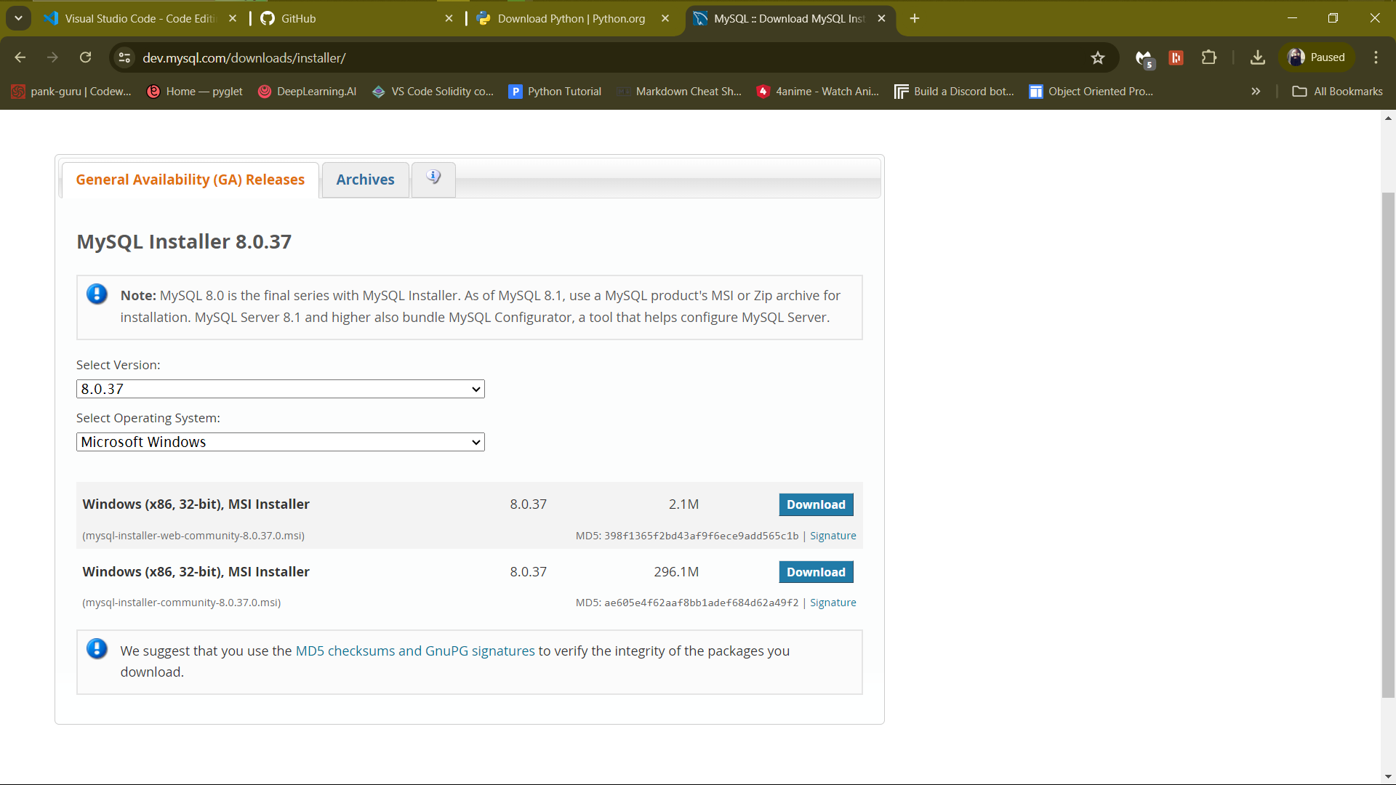

**2. Installation Process:**

- Run the MySQL Installer and follow the setup wizard.

- Choose the setup type (e.g., Developer Default).

- Configure MySQL Server settings, including the root password.

NB: MYSQL IS ALREADY CONFIGURED WITH PASSWORD

**3. Verify Installation:**

- Open MySQL Workbench or MySQL Shell and connect to your MySQL server.

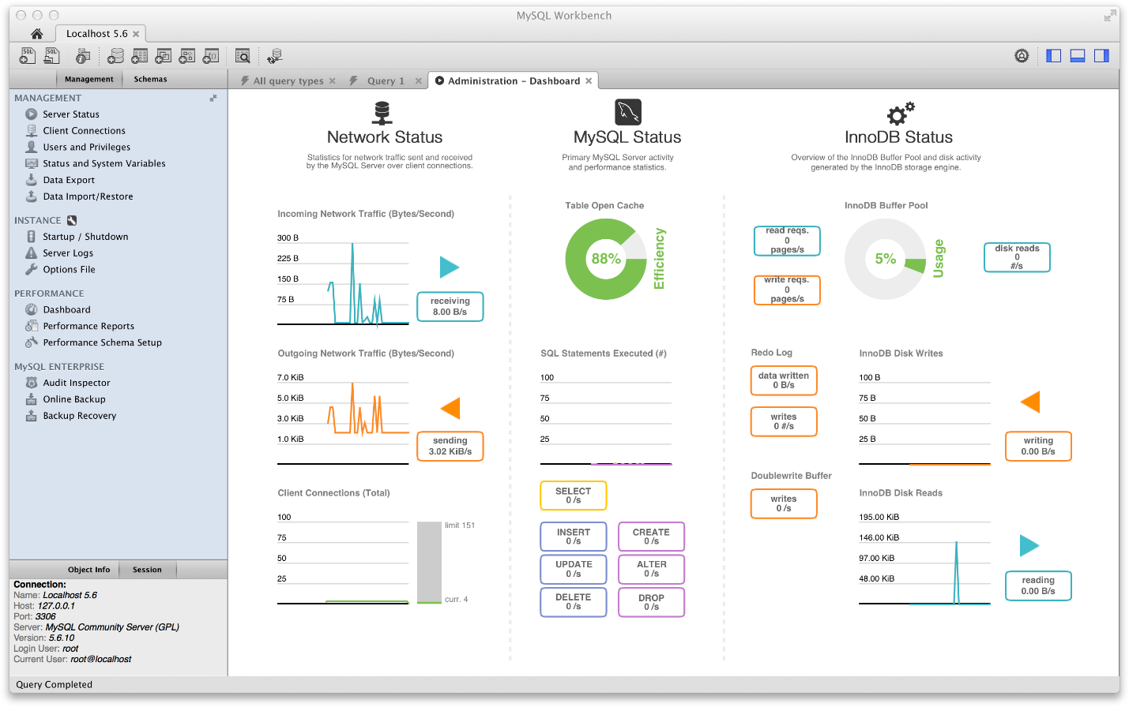

**7. Development Environments and Virtualization (Optional)**

Optional Steps for Installing and Setting Up Docker:

1. Download Docker:

- Visit the Docker Desktop download page: [Docker Download](https://www.docker.com/products/docker-desktop).

- Download and run the Docker Desktop installer.

![Docker Download](images/docker-download.png)

**2. Installation Process:**

- Follow the installation instructions.

- Start Docker Desktop and follow the setup wizard.

NB:NOT OPTED FOR

**3. Verify Installation:**

- Open Command Prompt or PowerShell and type:

```bash

docker --version

```

NB:NOT OPTED FOR

**8. Extensions and Plugins**

List of Installed Extensions for VS Code:

1. Install Extensions:

- Open VS Code.

- Go to the Extensions view (`Ctrl+Shift+X`).

- Search for and install the following extensions:

- Python

- GitLens — Git supercharged

- Docker

- Prettier - Code formatter

- ESLint

- MySQL

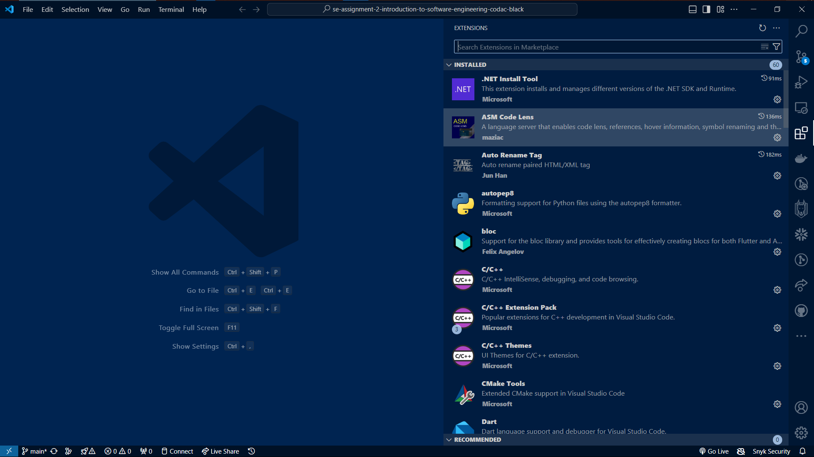

**3. Reflection:**

- Included in the Challenges and Solutions section.